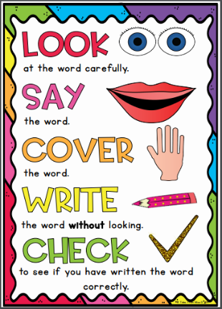
Amethyst Group
Weekly Spellings
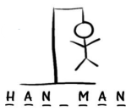
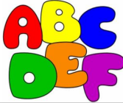
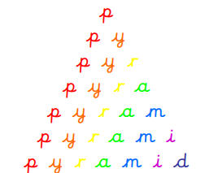
Spelling strategies:
- Rainbow writing
- Bubble writing
- Doodle words
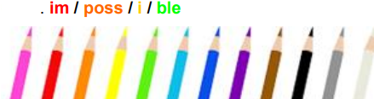
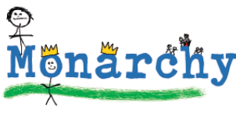
- Hangman
- Word pyramids

Test 1: Words ending in ‘ff’, ‘ll’, ‘ss’, ‘zz’ and ‘ck’ – Tested on Friday 18th September

puff
fluff
bell
doll
grass
kiss
buzz
fizz
clock
back

Test 2: Words with the /k/ sound spelled ‘k’ and ‘nk’ – Tested on Friday 25th September

bank
honk
tank
pink
think
kit
skin
mask
kick
basket

Test 3: Words with the ‘tch’ trigraph – Tested on Friday 2nd October

catch
fetch
kitchen
switch
hutch
witch
ditch
patch
match
batch

Test 4: Adding ‘-s’ and ‘-es’ to make plurals – Tested on Friday 9th October

flowers
boxes
brushes
lunches
cars
foxes
dogs
dishes
boats
churches

Test 5: Adding the suffixes ‘-ing’ and ‘-ed’ - Tested on Friday 16th October

looking
looked
buzzing
buzzed
jumping
jumped
helping
helped
fizzing
fizzed

Test 6: Adding the prefix ‘un-‘ and the suffixes ‘-er’ and ‘-est’ - Tested on Thursday 22nd October

fresher
higher
unload
unhappy
hardest
unfair
quicker
darkest
undo
unlock

