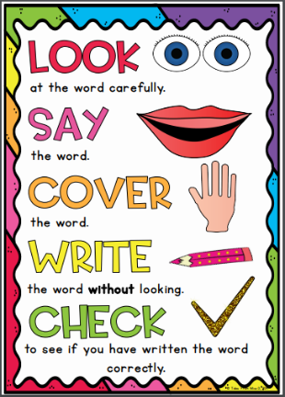
Diamond Group
Weekly Spellings

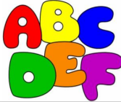
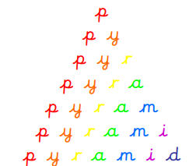
Spelling strategies:
- Rainbow writing
- Bubble writing
- Doodle words

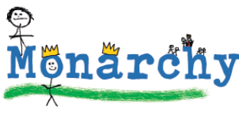
- Hangman
- Word pyramids

Test 1: Words where ‘dge’ makes a /j/ sound – Tested on Friday 18th September

badge
edge
bridge
dodge
fudge
ridge
smudge
judge
wedge
lodge

Test 2: Words where ‘ge’ makes a /j/ sound – Tested on Friday 25th September

change
charge
range
orange
hinge
strange
dungeon
sponge
pigeon
fringe

Test 3: Words where ‘g’ makes a /j/ sound – Tested on Friday 2nd October

gem
gym
giant
magic
giraffe
energy
digit
engine
religion
gentle

Test 4: Words where ‘c’ males a /s/ sound before ‘e’, ‘i’ and ‘y’ – Tested on Friday 9th October

race
ice
cell
city
fancy
lace
space
circle
circus
rice

Test 5: Words where ‘kn’ and ‘gn’ make a /n/ sound at the beginning of words - Tested on Friday 16th October

knock
know
knee
knew
kneel
knit
knight
gnome
gnat
gnaw

Test 6: Challenge words - Tested on Thursday 22nd October

door
floor
poor
find
kind
mind
behind
child
children
because

