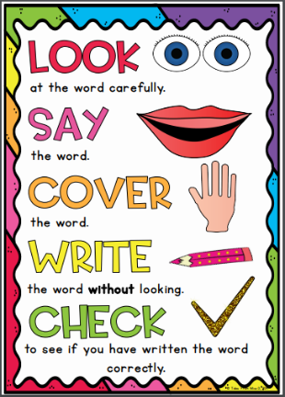
Emerald Group
Weekly Spellings

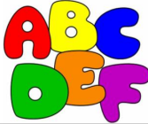
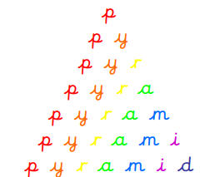
Spelling strategies:
- Rainbow writing
- Bubble writing
- Doodle words

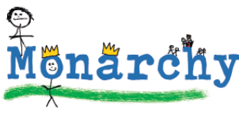
- Hangman
- Word pyramids

Test 1: Words that are homophones – Tested on Friday 18th September

accept
except
knot
not
peace
piece
plain
plane
weather
whether

Test 2: Words with the prefix ‘in-‘ meaning ‘not’ - Tested on Friday 25th September

inability
inactive
inadequate
incorrect
incurable
indefinite
inelegant
inflexible
insecure
invisible

Test 3: Words with the prefixes ‘il-‘, ‘im-‘ and ‘ir-‘ – Tested on Friday 2nd October

illegal
illegible
immature
immortal
impossible
impatient
imperfect
irregular
irrelevant
irresponsible

Test 4: Words with the prefix ‘sub-‘ meaning ‘below’ or ‘further divided’ – Tested on Friday 9th October

subdivide
subheading
subject
submarine
submerge
submit
substandard
subtitle
subtropical
subway

Test 5: Words with the prefix ‘inter-‘ meaning ‘between’ or ‘among’ - Tested on Friday 16th October

interact
intercept
interchange
intercity
intercom
interface
interfere
international
internet
interview

Test 6: Challenge words - Tested on Thursday 22nd October

strength
grammar
calendar
women
appear
straight
interest
opposite
increase
believe

