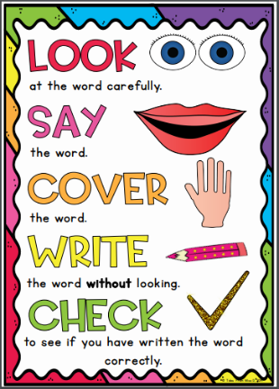
Sapphire Group
Weekly Spellings
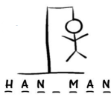
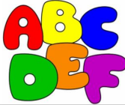
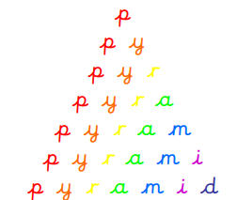
Spelling strategies:
- Rainbow writing
- Bubble writing
- Doodle words
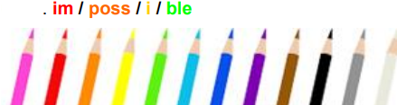
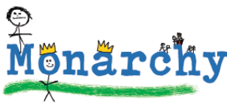
- Hangman
- Word pyramids

Test 1: Words where the diagraph ‘ou’ makes an /ow/ sound – Tested on Friday 18th September

mouth
sprout
around
sound
spout
ouch
hound
trout
found
proud

Test 2: Words where the diagraph ‘ou’ makes a /u/ sound – Tested on Friday 25th September

touch
double
country
trouble
young
cousin
enough
couple
encourage
flourish

Test 3: Words where ‘y’ makes an /i/ sound – Tested on Friday 2nd October

symbol
gym
myth
synonym
Egypt
lyrics
pyramid
system
mystery
gymnastics

Test 4: Words ending in ‘-sure’ – Tested on Friday 9th October

treasure
measure
leisure
pleasure
pressure
exposure
enclosure
closure
disclosure
composure

Test 5: Words ending in ‘-ture’ - Tested on Friday 16th October

adventure
future
picture
nature
creature
furniture
capture
sculpture
fracture
mixture

Test 6: Challenge words - Tested on Thursday 22nd October

actual
bicycle
answer
circle
earth
enough
island
fruit
often
popular

