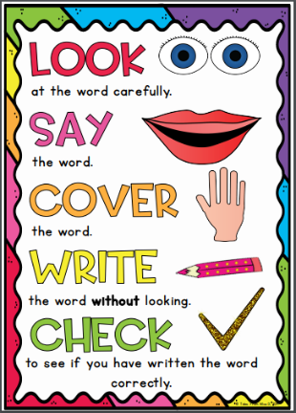
Topaz Group
Weekly Spellings

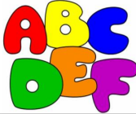
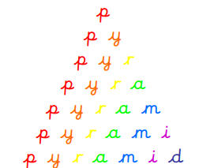
Spelling strategies:
- Rainbow writing
- Bubble writing
- Doodle words

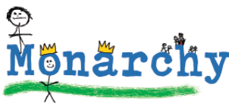
- Hangman
- Word pyramids

Test 1: Words with the suffix ‘-ous’ – Tested on Friday 18th September

ambitious
amphibious
curious
devious
fictitious
infectious
notorious
nutritious
repetitious
obvious

Test 2: Words with the suffix ‘-ous’ - Tested on Friday 25th September

atrocious
conscious
delicious
ferocious
gracious
luscious
malicious
precious
spacious
suspicious

Test 3: Words with the suffix ‘-al’ – Tested on Friday 2nd October

artificial
beneficial
crucial
especially
facial
glacial
judicial
multiracial
official
special

Test 4: Words with the suffix ‘-al’ – Tested on Friday 9th October

circumstantial
confidential
essential
impartial
influential
potential
preferential
residential
substantial
torrential

Test 5: Words with the suffix ‘-al’ - Tested on Friday 16th October

commercial
controversial
controversially
financial
financially
initial
initially
palatial
provincial
spatial

Test 6: Challenge words - Tested on Thursday 22nd October

appreciate
cemetery
conscious
convenience
environment
immediately
language
sufficient
thorough
vegetable

