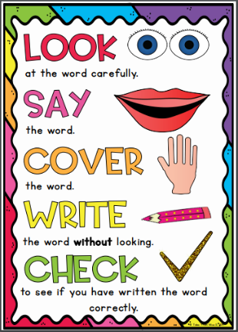
Emerald Group
Weekly Spellings

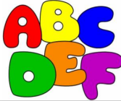
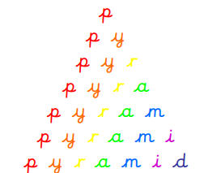
Spelling strategies:
- Rainbow writing
- Bubble writing
- Doodle words
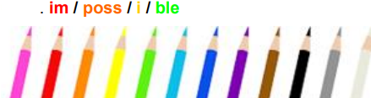
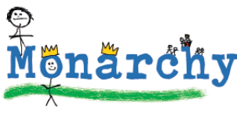
- Hangman
- Word pyramids

Test 1: Words with the suffixes ‘-ate’ and ‘-ion’ – Tested on Friday 13th November

information
vibration
decoration
donation
population
coronation
detonation
location
generation
illustration

Test 2: Words with the suffixes ‘-ate’ and ‘-ion’ - Tested on Friday 20th November

adoration
admiration
observation
exploration
combination
preparation
determination
sensation
duration
registration

Test 3: Words with the suffix ‘-ly’– Tested on Friday 27th November

sadly
completely
wildly
bravely
gently
foolishly
proudly
horribly
nervously
happily

Test 4: Words ending in ‘-lly’ – Tested on Friday 4th December

usually
finally
beautifully
thoughtfully
wonderfully
carefully
faithfully
peacefully
cruelly
generally

Test 5: Words where ‘ch’ makes a /sh/ sound - Tested on Friday 11th December

chef
chalet
machine
brochure
parachute
chute
chaperone
chandelier
crochet
quiche

Test 6: Challenge words - Tested on Friday 18th December

complete
continue
experiment
famous
favourite
February
naughty
material
knowledge
remember

