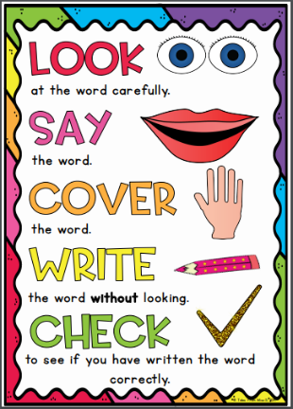
Topaz Group
Weekly Spellings

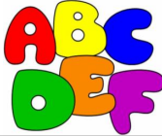
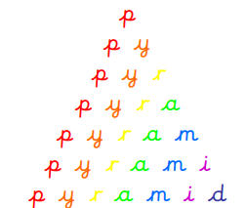
Spelling strategies:
- Rainbow writing
- Bubble writing
- Doodle words
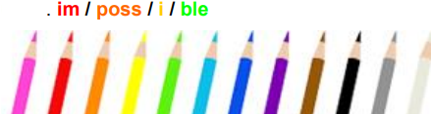
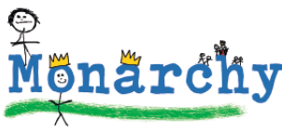
- Hangman
- Word pyramids

Test 1: Words with the ending ‘ant’ – Tested on Friday 13th November

abundant
brilliant
constant
distant
dominant
elegant
fragrant
ignorant
tolerant
vacant

Test 2: Words with the suffix ‘ance’ and ‘ancy’ - Tested on Friday 20th November

abundance
brilliance
elegance
tolerance
hesitancy
vacancy
abundancy
ambulance
circumstance
redundancy

Test 3: Words ending in ‘ent’ and ‘ence’ – Tested on Friday 27th November

innocence
frequent
emergent
confidence
competence
transparent
eloquence
violent
intelligence
decent

Test 4: Words with the suffix ‘able’ and ‘ible’ – Tested on Friday 4th December

dependable
comfortable
understandable
reasonable
enjoyable
reliable
possible
horrible
terrible
incredible

Test 5: Words ending in ‘ably’ and ‘ibly’ - Tested on Friday 11th December

reliably
dependably
comfortably
possibly
horribly
terribly
visibly
incredibly
sensibly
legibly

Test 6: Challenge words - Tested on Friday 18th December

accommodate
available
controversy
dictionary
marvellous
opportunity
secretary
sincerely
suggest
twelfth

