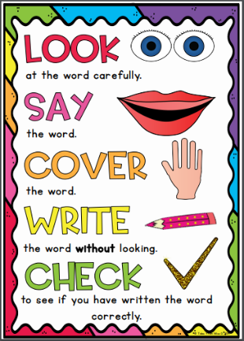
Diamond Group
Weekly Spellings
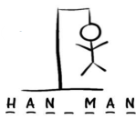
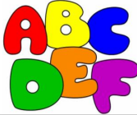
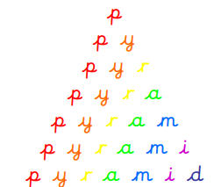
Spelling strategies:
- Rainbow writing
- Bubble writing
- Doodle words
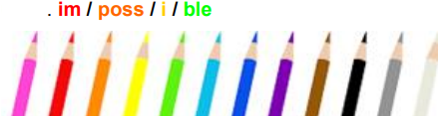
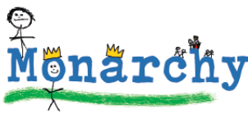
- Hangman
- Word pyramids

Test 1: Words where ‘wr’ makes a /r/ sound at the beginning of words - Tested on Friday 13th November
write
written
wrong
wrap
wren
wrecked
wrapped
wriggle
wrestle
wrote

Test 2: Words ending in ‘le’ – Tested on Friday 20th November

table
apple
bottle
little
middle
bubble
cable
uncle
ankle
eagle

Test 3: Words ending in ‘el’ – Tested on Friday 27th November

camel
tunnel
squirrel
travel
towel
tinsel
hazel
vowel
angel
jewel

Test 4: Words ending in ‘al’ – Tested on Friday 4th December

pedal
capital
hospital
animal
equal
final
petal
local
magical
metal

Test 5: Words ending in ‘il’ – Tested on Friday 11th December

pencil
fossil
nostril
pupil
April
gerbil
lentil
evil
anvil
basil

Test 6: Challenge words - Tested on Friday 18th December

wild
climb
most
only
both
old
cold
gold
hold
told

