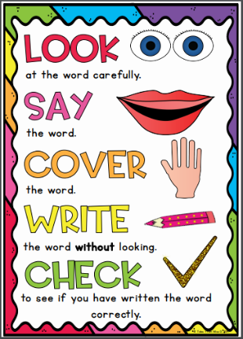
Opal Group
Weekly Spellings

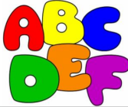
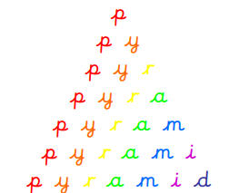
Spelling strategies:
- Rainbow writing
- Bubble writing
- Doodle words

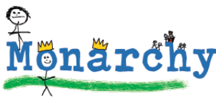
- Hangman
- Word pyramids

Test 1: Compound words and words with unstressed vowels – Tested on Friday 13th November

pocket
balloon
carrot
thunder
sunset
football
playground
farmyard
bedroom
starfish

Test 2: Words with the diagraphs ‘ai’ and ‘oi’ – Tested on Friday 20th November

rain
point
oil
wait
train
coin
join
paid
afraid
soil

Test 3: Words with the diagraphs ‘ay’ and ‘oy’ – Tested on Friday 27th November

day
play
cowboy
enjoy
stay
toy
joy
clay
say
way

Test 4: Words with the split diagraph ‘a_e’ – Tested on Friday 4th December

made
take
came
mistake
same
safe
awake
snowflakes
rake
plate

Test 5: Words with the split diagraph ‘e_e’ - Tested on Friday 11th December

even
complete
delete
Chinese
these
evening
eve
athlete
extreme
theme

Test 6: Words with the split diagraph ‘i_e’ - Tested on Thursday 18th December

five
ride
like
time
side
slide
spike
trike
fire
mine

