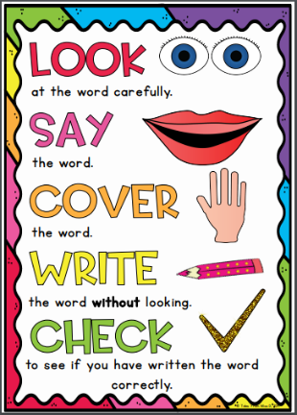
Sapphire Group
Weekly Spellings


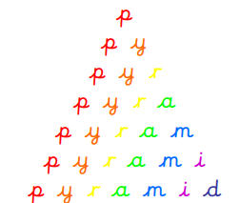
Spelling strategies:
- Rainbow writing
- Bubble writing
- Doodle words

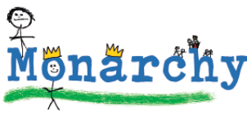
- Hangman
- Word pyramids

Test 1: Words with the prefix ‘re’– Tested on Friday 13th November

redo
refresh
return
reappear
redecorate
revenge
review
replay
reaction
rebound

Test 2: Words with the prefix ‘dis’ – Tested on Friday 20th November

disappoint
disagree
disobey
disable
dislike
dislocate
disappear
disadvantage
disapprove
dislodge

Test 3: Words with the prefix ‘mis’ Tested on Friday 27th November

misbehave
mislead
misspell
mistake
misplace
misread
mistrust
misunderstanding
misuse
mislaid

Test 4: Words where ‘-ing’, ‘-er’ and ‘-ed’ are added to multi-syllabic words – Tested on Friday 4th December

gardening
limited
limiting
developing
developed
listening
listened
covered
covering
gardener

Test 5: Words where ‘-ing’, ‘-en’ and ‘-ed’ are added to multi-syllabic words - Tested on Friday 11th December

forgetting
forgotten
beginning
preferred
permitted
regretting
committed
forbidden
propelled
equipped

Test 6: Challenge words - Tested on Friday 18th December

centre
decide
disappear
early
heart
learn
minute
notice
regular
therefore

